

TECHNICAL UNIVERSITY OF KENYA
FACULTY OF APPLIED SCIENCES AND TECHNOLOGY
SCHOOL OF COMPUTING & INFORMATION TECHNOLOGY
END OF SEMESTER MAY 2017 EXAMINATION SERIES
FIRST SEMESTER EXAMINATIONS 2016/2017
THIRD YEAR EXAMINATIONS FOR THE DEGREE OF
BACHELOR OF TECHNOLOGY IN COMMUNICATION AND COMPUTER NETWORKS
ECCI 3103: ROUTING AND ROUTING PROTOCOLS
TIME: 2 Hours MAY 2017
Instructions to candidates:
This paper consists of FIVE Questions.
Answer Question ONE [30 Marks] and any other TWO Questions [20 Marks Each].
Mobile phones and any written materials are prohibited in the examination room.
Programmable calculators are prohibited
Write your college number on the answer sheet.
This paper consists of 3 printed pages
Candidates should check the question paper to ascertain that all the pages are printed as indicated and that no questions are missing.

QUESTION 1 [30 Marks]
a) Describe the ISO OSI model, outlining the functions of and protocols used in each of the layers. (10 Marks).
b) What are the primary threats to Network Security. (4 Marks)
c) XYZ School further wants to place ACL (Access Control Lists) in the network.
Discuss the purpose and importance of ACL (Access Control Lists). (6 Marks)
d) How does ARP (Address Resolution Protocol) and Proxy ARP work ? Explain in detail(7 Marks)
e) Discuss the vulnerabilities of ARP. (3 Marks)

QUESTION 2 [20 Marks]
a) Discuss the following terms
i) IGRP (Interior Gateway Routing Protocol) (2 Marks)
ii) BGP (Border gateway protocol) (2 Marks)
iii) RIP (Routing Internet Protocol)(2 Marks)
v) EIGRP (Enhanced Interior Gateway Routing Protocol) (2 Marks)
vi) OSPF (Open Shortest Path First) (2 Marks)

b) Given the router configuration below, describe how distance vector
Routing protocol works. (10 Marks)

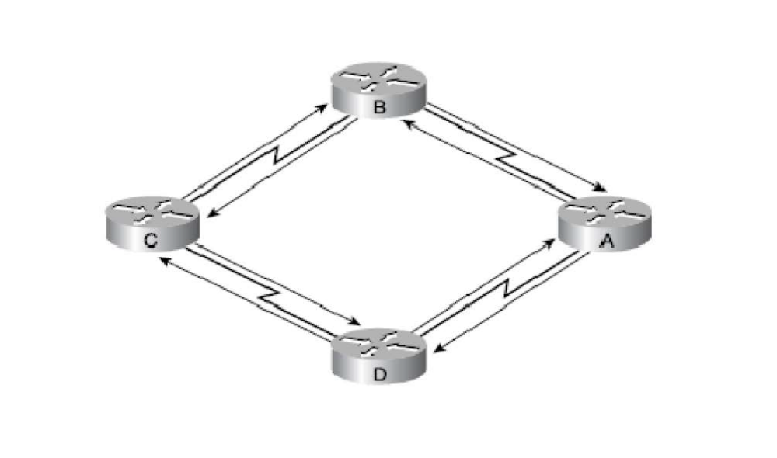

QUESTION 3 [20 Marks]
a) Describe Router interfaces (6Marks)
b) Name the two (2) Router interfaces and their functions (4Marks)
c) Describe Routing and layer used on the OSI model (4Marks)
d) Using the diagram below, draw an OSI model, and describe the operation layers and forwarding layer (6Marks)
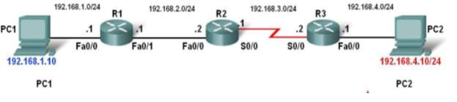

QUESTION 4 [20 Marks]
- Describe Routing Table (5 Marks)
- write brief notes on (6 Marks)
- Static and
- Dynamic Routing Protocols
- List advantages and disadvantages of (6 Marks)
- static Routing
- Dynamic Routing
- List the three(3) main categories of Routers in use today
by companies (3 Marks)

QUESTION 5 [20 Marks]
- A ‘generic’ Router has four components, List and explain their (8 Marks)
Functions
- List the three(3) switching techniques used by a router’s (3 Marks)
Switching fabric
- List the basic things that need to be configured on a router (6 Marks)
Before it can be used for its primary function
- Differentiate between firewall and Router (3 Marks)

